NIFTY Weekly Options Quantitative Trading Model — Execution Plan
Here's a comprehensive, phased plan to build this system end-to-end.

Phase 1: Architecture Overview

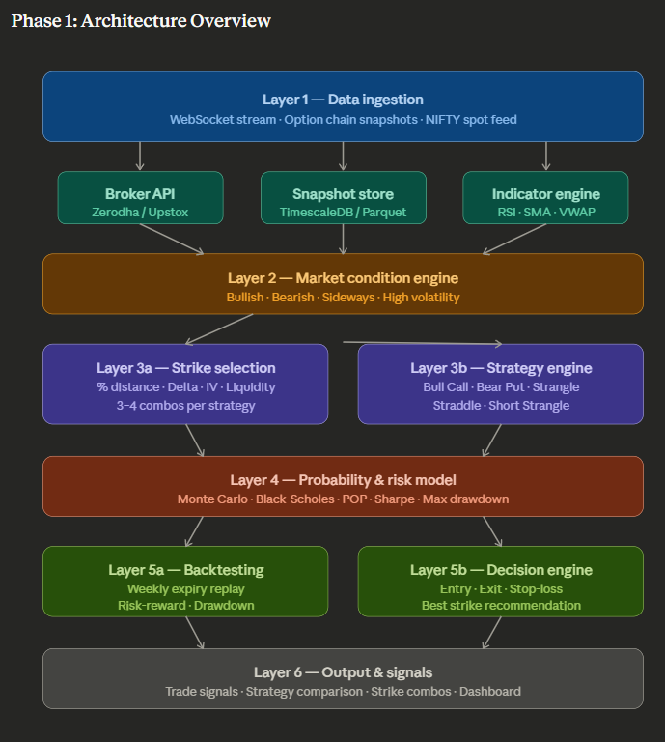

Phase 2: Project Structure & Module Breakdown
nifty_options_model/
├── config/
│ └── settings.py # API keys, parameters, thresholds
├── data/
│ ├── broker_api.py # Zerodha/Upstox connection layer
│ ├── websocket_feed.py # Real-time streaming handler
│ ├── snapshot_store.py # DB write / Parquet archiver
│ └── schema.py # Data models (see schema section)
├── indicators/
│ └── technical.py # RSI, SMA, VWAP, Bollinger Bands
├── market_condition/
│ └── classifier.py # Bullish / Bearish / Sideways engine
├── options/
│ ├── chain_processor.py # Option chain parsing & enrichment
│ ├── greeks.py # Delta, Theta, Vega calculations
│ └── liquidity_filter.py # OI, Volume, Bid-Ask filter
├── strategy/
│ ├── bull_call_spread.py
│ ├── bear_put_spread.py
│ ├── strangle.py
│ └── straddle.py
├── strike_selection/
│ └── selector.py # Delta / %OTM / IV based combos
├── probability/
│ ├── monte_carlo.py
│ ├── black_scholes.py
│ └── pop_estimator.py
├── backtest/
│ ├── engine.py # Weekly expiry replay loop
│ └── metrics.py # Sharpe, drawdown, POP, R:R
├── decision/
│ └── engine.py # Signal generator + strategy mapper
├── output/
│ └── dashboard.py # Console / HTML report / alerts
└── main.py # Entry point

Phase 3: Data Schema
# schema.py — Option chain snapshot (one row per strike per timestamp)

from dataclasses import dataclass
from datetime import datetime
from typing import Optional

@dataclass
class OptionChainSnapshot:
# ── Identity ──────────────────────────────────────────
timestamp: datetime # Snapshot capture time (IST)
expiry_date: str # e.g. "2024-01-25" (weekly Thursday)
spot_price: float # NIFTY index level
strike_price: float # Strike (e.g. 21800)
instrument_type: str # "CE" or "PE"

# ── Pricing ───────────────────────────────────────────
ltp: float # Last traded price
bid: Optional[float]
ask: Optional[float]
bid_ask_spread: Optional[float]

# ── Volatility & Time ─────────────────────────────────
iv: float # Implied volatility (annualised %)
time_to_expiry: float # In calendar days (fractional)
tte_trading_days: float # In trading days

# ── Volume & Interest ─────────────────────────────────
volume: int
open_interest: int
oi_change: int # OI change vs previous snapshot

# ── Greeks ────────────────────────────────────────────
delta: Optional[float]
theta: Optional[float]
vega: Optional[float]
gamma: Optional[float]

# ── Derived / Technical ───────────────────────────────
moneyness: str # "ITM", "ATM", "OTM"
distance_from_atm_pct: float # (strike - spot) / spot * 100
rsi_14: float # RSI at snapshot time
sma_20: float # 20-period SMA of NIFTY
sma_50: float # 50-period SMA of NIFTY
market_condition: str # "bullish" / "bearish" / "sideways"
vwap: Optional[float]

# ── Storage schema (SQL / TimescaleDB) ────────────────────
"""
CREATE TABLE option_chain (
timestamp TIMESTAMPTZ NOT NULL,
expiry_date DATE NOT NULL,
spot_price NUMERIC(10,2),
strike_price NUMERIC(10,2),
instrument_type CHAR(2),
ltp NUMERIC(10,2),
bid NUMERIC(10,2),
ask NUMERIC(10,2),
iv NUMERIC(6,4),
time_to_expiry NUMERIC(6,4),
volume INTEGER,
open_interest INTEGER,
oi_change INTEGER,
delta NUMERIC(6,4),
theta NUMERIC(8,4),
vega NUMERIC(8,4),
rsi_14 NUMERIC(6,4),
sma_20 NUMERIC(10,2),
sma_50 NUMERIC(10,2),
market_condition VARCHAR(12),
PRIMARY KEY (timestamp, strike_price, instrument_type, expiry_date)
);
SELECT create_hypertable('option_chain', 'timestamp');
"""

Phase 4: Sample Python Code Structure
4.1 — WebSocket Feed & Snapshot Collector
# data/websocket_feed.py
import asyncio
import json
from datetime import datetime
from kiteconnect import KiteTicker
from snapshot_store import SnapshotStore
from options.chain_processor import enrich_snapshot

class NiftyOptionsFeed:
def __init__(self, api_key, access_token, store: SnapshotStore):
self.kws = KiteTicker(api_key, access_token)
self.store = store
self.tokens = [] # instrument tokens for NIFTY options chain

def load_option_tokens(self, chain_fetcher):
"""Fetch ATM ±5 strikes (CE + PE) for weekly expiry."""
self.tokens = chain_fetcher.get_weekly_tokens(strikes_range=5)
return self.tokens

def start(self):
self.kws.on_ticks = self._on_ticks
self.kws.on_connect = self._on_connect
self.kws.on_close = self._on_close
self.kws.connect(threaded=True)

def _on_connect(self, ws, response):
ws.subscribe(self.tokens)
ws.set_mode(ws.MODE_FULL, self.tokens)

def _on_ticks(self, ws, ticks):
ts = datetime.now()
for tick in ticks:
snapshot = enrich_snapshot(tick, ts)
if snapshot:
self.store.write(snapshot)

def _on_close(self, ws, code, reason):
print(f"[WebSocket closed] {code}: {reason}")
# Implement reconnect logic here
4.2 — Technical Indicators
# indicators/technical.py
import pandas as pd
import numpy as np

def compute_rsi(prices: pd.Series, period: int = 14) -> float:
delta = prices.diff()
gain = delta.clip(lower=0).rolling(period).mean()
loss = (-delta.clip(upper=0)).rolling(period).mean()
rs = gain / loss
return float(100 - (100 / (1 + rs.iloc[-1])))

def compute_sma(prices: pd.Series, period: int) -> float:
return float(prices.rolling(period).mean().iloc[-1])

def compute_vwap(df: pd.DataFrame) -> float:
"""df must have 'close', 'volume', 'high', 'low' columns."""
tp = (df['high'] + df['low'] + df['close']) / 3
return float((tp * df['volume']).sum() / df['volume'].sum())

def classify_market(spot: float, rsi: float,
sma20: float, sma50: float,
iv_current: float, iv_avg: float) -> str:
if rsi > 60 and spot > sma20 > sma50:
return "bullish"
elif rsi < 40 and spot < sma20 < sma50:
return "bearish"
elif iv_current > iv_avg * 1.25:
return "high_volatility"
else:
return "sideways"
4.3 — Strike Selection Logic
# strike_selection/selector.py
from dataclasses import dataclass
from typing import List
import pandas as pd

@dataclass
class StrikeCombo:
label: str # e.g. "delta_0.3"
buy_strike: float
sell_strike: float
buy_ltp: float
sell_ltp: float
net_premium: float
max_profit: float
max_loss: float
breakeven: float
buy_delta: float
sell_delta: float
buy_iv: float
sell_iv: float

class StrikeSelector:
def __init__(self, chain_df: pd.DataFrame, spot: float,
lot_size: int = 50):
self.chain = chain_df
self.spot = spot
self.lot_size = lot_size

def _liquidity_ok(self, row, min_oi=50000, min_vol=500,
max_spread_pct=0.05) -> bool:
spread_ok = (row['ask'] - row['bid']) / row['ltp'] < max_spread_pct
return row['open_interest'] >= min_oi \
and row['volume'] >= min_vol \
and spread_ok

def get_bull_call_combos(self) -> List[StrikeCombo]:
calls = self.chain[self.chain['instrument_type'] == 'CE']
combos = []
# Method 1: % distance from spot
for pct in [0.01, 0.02, 0.03]:
buy = self._nearest_strike(calls, self.spot)
sell = self._nearest_strike(calls, self.spot * (1 + pct))
if self._liquidity_ok(buy) and self._liquidity_ok(sell):
combos.append(self._build_spread(
f"pct_{int(pct*100)}%", buy, sell, 'CE'))

# Method 2: Delta-based (buy ~0.5, sell ~0.3)
for buy_d, sell_d in [(0.5, 0.3), (0.4, 0.2)]:
buy = self._by_delta(calls, buy_d)
sell = self._by_delta(calls, sell_d)
if buy is not None and sell is not None:
combos.append(self._build_spread(
f"delta_{buy_d:.1f}_{sell_d:.1f}", buy, sell, 'CE'))
return combos

def _nearest_strike(self, df, target) -> pd.Series:
idx = (df['strike_price'] - target).abs().idxmin()
return df.loc[idx]

def _by_delta(self, df, target_delta) -> pd.Series:
candidates = df[df['delta'].notna()]
idx = (candidates['delta'] - target_delta).abs().idxmin()
return candidates.loc[idx]

def _build_spread(self, label, buy_row, sell_row,
opt_type) -> StrikeCombo:
net = buy_row['ltp'] - sell_row['ltp']
width = sell_row['strike_price'] - buy_row['strike_price']
return StrikeCombo(
label=label,
buy_strike=buy_row['strike_price'],
sell_strike=sell_row['strike_price'],
buy_ltp=buy_row['ltp'], sell_ltp=sell_row['ltp'],
net_premium=net * self.lot_size,
max_profit=(width - net) * self.lot_size,
max_loss=net * self.lot_size,
breakeven=buy_row['strike_price'] + net,
buy_delta=buy_row.get('delta', 0),
sell_delta=sell_row.get('delta', 0),
buy_iv=buy_row['iv'], sell_iv=sell_row['iv']
)
4.4 — Probability & Monte Carlo Engine
# probability/monte_carlo.py
import numpy as np
from scipy.stats import norm

def black_scholes_pop(spot, strike, tte_years, iv, risk_free=0.065) -> float:
"""Probability that option expires ITM (risk-neutral measure)."""
d2 = (np.log(spot / strike) + (risk_free - 0.5 * iv**2) * tte_years) \
/ (iv * np.sqrt(tte_years))
return float(norm.cdf(d2)) # for calls; 1 - N(d2) for puts

def monte_carlo_pop(spot, mu_daily, sigma_daily, tte_days,
target_price, n_sims=50000) -> float:
"""
Historical distribution-based POP.
mu_daily: mean daily log return of NIFTY
sigma_daily: std dev of daily log returns
"""
rng = np.random.default_rng(42)
log_returns = rng.normal(mu_daily, sigma_daily, (n_sims, tte_days))
terminal = spot * np.exp(log_returns.sum(axis=1))
return float((terminal >= target_price).mean())

def spread_expected_payoff(spot, buy_strike, sell_strike,
iv, tte_years, n_sims=50000,
spread_type='bull_call') -> dict:
"""Returns POP, expected payoff, and risk-reward for a spread."""
rng = np.random.default_rng(0)
paths = spot * np.exp(
(0.065 - 0.5 * iv**2) * tte_years +
iv * np.sqrt(tte_years) * rng.standard_normal(n_sims)
)
width = sell_strike - buy_strike
if spread_type == 'bull_call':
payoffs = np.clip(paths - buy_strike, 0, width) \
- np.clip(paths - sell_strike, 0, width)
else: # bear_put
payoffs = np.clip(buy_strike - paths, 0, width) \
- np.clip(sell_strike - paths, 0, width)
return {
"pop": float((payoffs > 0).mean()),
"expected_payoff": float(payoffs.mean()),
"max_profit": float(payoffs.max()),
"max_loss": float(payoffs.min()),
"risk_reward": abs(payoffs[payoffs>0].mean()
/ payoffs[payoffs<0].mean())
if (payoffs < 0).any() else float('inf')
}
4.5 — Backtesting Framework
# backtest/engine.py
import pandas as pd
from dataclasses import dataclass, field
from typing import List
from probability.monte_carlo import spread_expected_payoff

@dataclass
class BacktestTrade:
expiry: str
strategy: str
combo_label: str
entry_premium: float
exit_premium: float
pnl: float
pnl_pct: float
won: bool

@dataclass
class BacktestResult:
strategy: str
trades: List[BacktestTrade] = field(default_factory=list)

@property
def total_pnl(self): return sum(t.pnl for t in self.trades)
@property
def win_rate(self): return sum(t.won for t in self.trades) / len(self.trades)
@property
def avg_rr(self):
wins = [t.pnl for t in self.trades if t.won]
losses = [abs(t.pnl) for t in self.trades if not t.won]
return (sum(wins)/len(wins)) / (sum(losses)/len(losses)) \
if losses else float('inf')
@property
def sharpe(self):
pnls = pd.Series([t.pnl_pct for t in self.trades])
return float((pnls.mean() / pnls.std()) * (52**0.5)) \
if pnls.std() > 0 else 0.0
@property
def max_drawdown(self):
cumulative = pd.Series([t.pnl for t in self.trades]).cumsum()
peak = cumulative.cummax()
return float((cumulative - peak).min())

class BacktestEngine:
def __init__(self, historical_db):
self.db = historical_db # Interface to stored snapshots

def run(self, start_date: str, end_date: str,
strategies: list) -> dict:
expiries = self.db.get_expiry_dates(start_date, end_date)
results = {s: BacktestResult(s) for s in strategies}

for expiry in expiries:
entry_chain = self.db.get_chain_at_open(expiry)
exit_chain = self.db.get_chain_at_expiry(expiry)
indicators = self.db.get_indicators_at_open(expiry)

for strategy in strategies:
trade = self._simulate_trade(
strategy, entry_chain, exit_chain, indicators)
if trade:
results[strategy].trades.append(trade)

return {k: self._summarise(v) for k, v in results.items()}

def _simulate_trade(self, strategy, entry, exit_chain, indicators):
# Strategy-specific entry logic
# Returns BacktestTrade or None (if no valid signal)
pass

def _summarise(self, result: BacktestResult) -> dict:
return {
"win_rate": result.win_rate,
"sharpe": result.sharpe,
"max_drawdown": result.max_drawdown,
"avg_rr": result.avg_rr,
"total_pnl": result.total_pnl,
"n_trades": len(result.trades)
}
4.6 — Decision Engine (Strategy Mapper + Signal Generator)
# decision/engine.py
from dataclasses import dataclass
from typing import Optional, List
from strike_selection.selector import StrikeSelector, StrikeCombo

@dataclass
class TradeSignal:
strategy: str
combo: StrikeCombo
entry_price: float
stop_loss: float
target_price: float
pop: float
expected_payoff: float
risk_reward: float
confidence: str # "high" / "medium" / "low"
rationale: str

class DecisionEngine:
STRATEGY_MAP = {
"bullish": ["bull_call_spread"],
"bearish": ["bear_put_spread"],
"sideways": ["short_strangle", "short_straddle"],
"high_volatility":["long_strangle", "long_straddle"],
}

def __init__(self, selector: StrikeSelector, prob_model,
min_rr: float = 1.5, min_pop: float = 0.45):
self.selector = selector
self.prob = prob_model
self.min_rr = min_rr
self.min_pop = min_pop

def generate_signals(self, market_condition: str,
spot: float, iv: float,
tte_days: float) -> List[TradeSignal]:
strategies = self.STRATEGY_MAP.get(market_condition, [])
signals = []

for strategy in strategies:
combos = self._get_combos(strategy)
for combo in combos:
stats = self.prob.evaluate(
combo, spot, iv, tte_days, strategy)
if stats['risk_reward'] >= self.min_rr \
and stats['pop'] >= self.min_pop:
signals.append(TradeSignal(
strategy=strategy,
combo=combo,
entry_price=combo.net_premium,
stop_loss=combo.net_premium * 1.5,
target_price=combo.max_profit * 0.75,
pop=stats['pop'],
expected_payoff=stats['expected_payoff'],
risk_reward=stats['risk_reward'],
confidence=self._confidence(stats),
rationale=self._build_rationale(
strategy, market_condition, stats)
))

return sorted(signals,
key=lambda s: s.risk_reward, reverse=True)

def _confidence(self, stats) -> str:
if stats['pop'] > 0.60 and stats['risk_reward'] > 2.0:
return "high"
elif stats['pop'] > 0.50 and stats['risk_reward'] > 1.5:
return "medium"
return "low"

def _build_rationale(self, strategy, condition, stats) -> str:
return (f"{strategy.replace('_',' ').title()} selected for "
f"{condition} market. POP={stats['pop']:.0%}, "
f"R:R={stats['risk_reward']:.1f}x")

def _get_combos(self, strategy):
dispatch = {
"bull_call_spread": self.selector.get_bull_call_combos,
"bear_put_spread": self.selector.get_bear_put_combos,
"long_strangle": self.selector.get_long_strangle_combos,
"short_strangle": self.selector.get_short_strangle_combos,
}
return dispatch.get(strategy, lambda: [])()

Phase 5: Decision Logic Flowchart
Here's how a live signal cycle flows from market data to trade output:

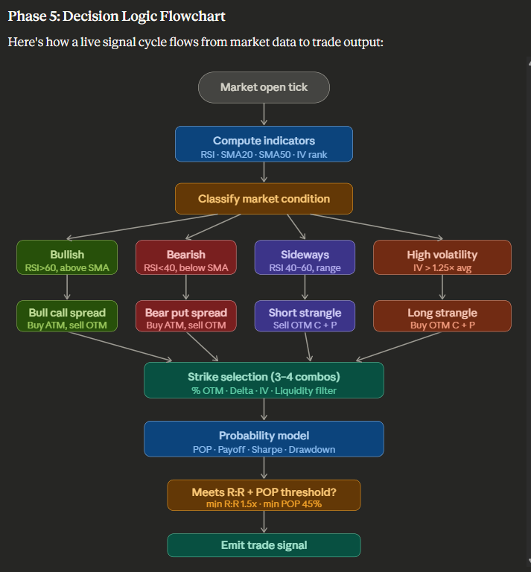
Phase 6: Execution Roadmap
Phase | Milestone | Duration
1 | Broker API setup, WebSocket feed, snapshot DB live | Immediate
2 | Indicator engine + market condition classifier
3 | Option chain processor + liquidity filter
4 | Strike selector (all methods) + Greeks
5 | Probability models (B-S + Monte Carlo)
6 | Strategy modules (all 5 strategies)
7 | Backtest engine + metrics
8 | Decision engine + signal generator
9 | Dashboard + alerting
10 | Paper trading validation → live

Key Design Decisions & Recommendations
Data source: Start with Zerodha Kite Connect — it gives WebSocket tick data, full option chain, and decent Greeks. Upstox is a viable alternative with marginally better API latency.
Storage: Use TimescaleDB (Postgres extension) for real-time tick storage. Archive weekly expiry snapshots to Parquet files for backtesting — Parquet + DuckDB gives sub-second query performance on years of data.
Greeks: If the broker doesn't provide real-time Greeks, compute Delta and Vega locally using py_vollib or mibian. Delta is critical for strike selection; Vega matters most for Strangle/Straddle sizing.
Probability model priority: Start with Black-Scholes POP for speed, layer in Monte Carlo for more realistic tail estimation. Use historical return distribution (not normal) once you have 6+ months of NIFTY data — Indian markets have fatter tails.
Backtesting pitfall: NIFTY weekly options suffer from liquidity collapse in the last 30 minutes of expiry Thursday. Model exit prices conservatively (use mid of bid-ask, not LTP) to avoid overfit results.
Risk management: Hard-code max loss per trade at 2% of capital in settings.py. The stop-loss at 1.5× premium is a starting point — calibrate this from your backtest results.
The next step would be to build out each module one at a time, starting with the data pipeline. Would you like me to generate the complete, production-ready code for any specific module?

